NEWSLETTER

SBA SWUFE

Index
The Fourth Online Lecture of Lecture Series "Dialogue with Corporate Executives" Held Successfully 1
Yunnan Alumni of School of Business Administration Contributed Their Support to Poverty-stricken Area 1
Professors from School of Business Administration offered advices on economic development of Sichuan province at the meeting of CPPCC Provincial Committee 2
SWUFERS Made a Historic Breakthrough in the 2020 American Mathematical Contest in Modeling 3

International Affairs Office and Sino-French Innovation Research Center
School of Business Administration
Southwestern University of Finance and Economics

May 2020

NEWSLETTER

The Fourth Online Lecture of Lecture Series "Dialogue with Corporate Executives" Held Successfully

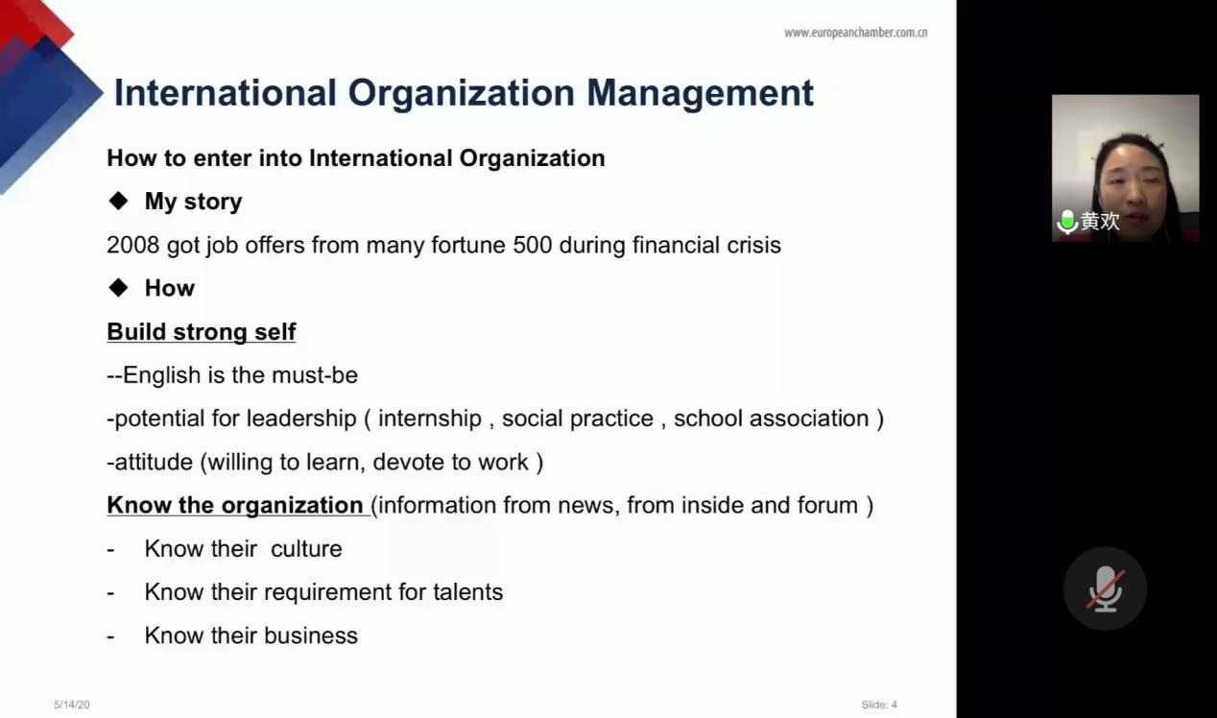
On the evening of May 14th 2020, the forth lecture of lecture series "Dialogue with Corporate Executives" hosted by the Nantes Project Office of the School of Business Administration of Southwestern University of Finance and Economics held successfully online. Mrs. Huang Huan, master of Public Administration, general manager of southwestern branch of European Union Chamber of Commerce in China, was invited as keynote speaker in today’s lecture themed as "Team management Skills in International Corporate".

Mrs. Huang used to hold the position of area leader in China in P&G, fully in charge of the retail services in Guangxi and Chongqing. Rich working experience in international corporate bring her up a wealth of experience in channel, brand and team management.

Through her comprehension on team management in international corporate, Mrs. Huang shared how to “manage up” and “manage down”. On the other hand, getting familiar with foreign culture and showing respect to each custom is also emphasized.
This is the fourth lecture of "Dialogue with Corporate Executives" lecture series, and speech of the expertise benefit the students a great deal.

Yunnan Alumni of School of Business Administration Contributed Their Support to Poverty-stricken Area
On the afternoon of May 17, the Yunnan Alumni Association of the School of Business Administration of Southwestern University of Finance and Economics successfully held its first meeting since establishment and discussed the poverty alleviation work and the 95th anniversary celebration of SWUFE.
Mr Chen Wei, president of Yunnan Alumni Association, first read out the "Poverty Alleviation Proposal of the School of Business Administration of SWUFE" at the meeting. Alumni actively responded to the school's call and contributed personal support according to their actual situation. Alumni present at the scene said that in this special period of national anti-epidemic, all men from SBA will continue to participate actively in the poverty alleviation work together and buy Fugong agricultural products, presenting a special birthday gift for the upcoming 95th anniversary of the alma mater!
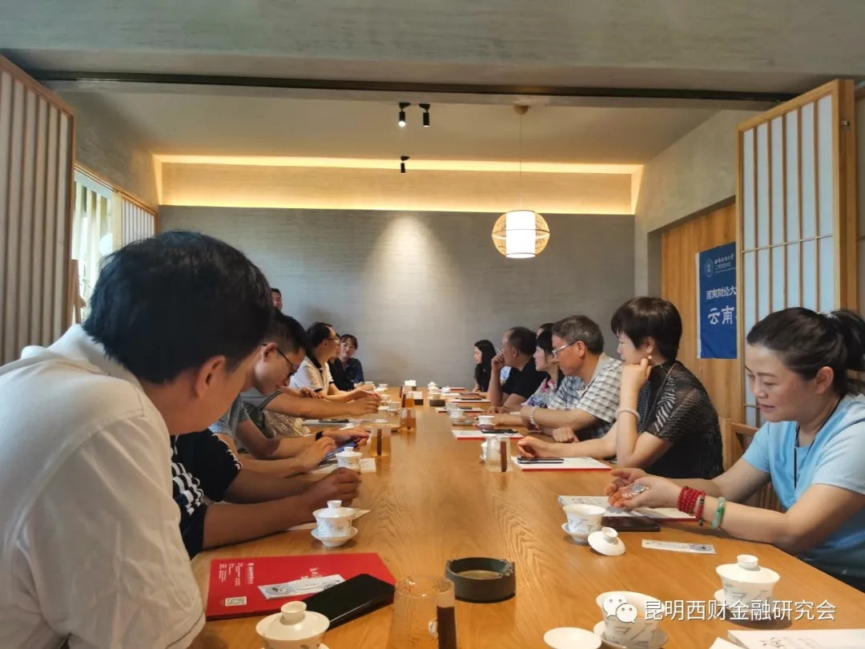
SWUFE was the home of the students when they are at university and the alumni association is the bond of the students after graduation. Thanks to all SWUFE alumni and SBA alumni for supporting each other during this special period, and using a strong and united alumni force to lay a solid foundation for school's work!

Professors from School of Business Administration offered advices on economic development of Sichuan province at the meeting of CPPCC Provincial Committee

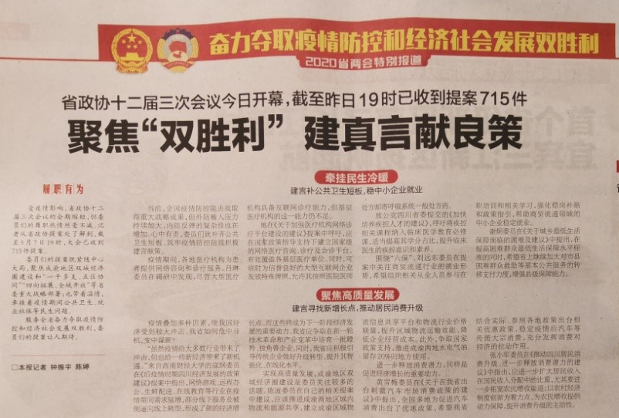
On May 8th, Sichuan Daily reported that Kou Gang, member of the Standing Committee of Sichuan Provincial Committee of the Chinese People's Political Consultative Conference and executive dean of our school, participated in the third meeting of the 12th CPPCC Provincial Committee and submitted a proposal , "Policy Recommendations for Sichuan Economic Development in the Post-epidemic Period." Based on the possible continuing impact of the epidemic, Mr. Kou Gang pointed out that Sichuan Province needs to find new economic growth points in the next stage, and suggested actively cultivating high-tech enterprises and guide traditional enterprises to upgrade and transform, so as to seize the new opportunities for economic development during the post-epidemic period.

SWUFERS Made a Historic Breakthrough in the 2020 American Mathematical Contest in Modeling

At the beginning of May, the results of the 2020 American Mathematical Contest in Modeling (MCM/ICM) were announced. Our school team hit a new high on the basis of its outstanding achievements at last year, raising to top ranking of all teams around the world, hornored 1 Outstanding Winners, 12 Finalist Winners, 23 Meritorious Winners, 68 Honorable Mentions and for the first time won INFORMS Award of American Association for Operations Research and Management.

The American College Students Mathematical Modeling Competition is hosted by COMAP (the Consortium for Mathematics and Its Application) and is the only international mathematical modeling competition with wide influence in the world. A total of Outstanding Winner Grand Prize, Finalist Winner Grand Prize, Meritorious Winner First Prize and Honorable Mention Winner Second Prize were selected in the competition. This competition includes 20950 teams from Peking University, Tsinghua University, Shanghai Jiao Tong University, Washington University, New York University, University of Toronto, Nanyang Technological University participated in the competition, and 37 teams won special prizes.

This competition was held on February 13th (Beijing time February 14th) and March 5th (Beijing time March 6th) during the prevention and control of the New coronavirus epidemic, and 296 teams, Nearly 900 students participated. The representatives of SWUFE achieved proud results during this special period.

