NEWSLETTER

SBA SWUFE

Index
SWUFE Held Flag-Raising Ceremony to Celebrate the 70th Anniversary of the Founding of the People’s Republic of China 1
SBA Teachers and Staff Watched the Celebration of the 70th Anniversary of the Founding of The People’s Republic of China 1
Exchange Ideas of Higher Education in Chinese and French Joint Degree Programme 2
Award Ceremony the 6th Industrial Economics Thesis Competition 2
Practical Teaching Activity of Transportation Organization and Management Course: Visit to China Tobacco Sichuan Industrial Co., Ltd. 3
The 7th Female Entrepreneurs Programme Opened Classes and 96 Female Entrepreneurs Bloom "Her Power" 3
International Students Visited Panda Base 4
Exploring Innovation Management in Business Plan Seminar 4
Free Shared Umbrellas were Provided 5
SBA International Students Participated in 2019 SWUFE Sports Meeting 5

International Affairs Office and Sino-French Innovation Research Center
School of Business Administration
Southwestern University of Finance and Economics

October 2019

NEWSLETTER

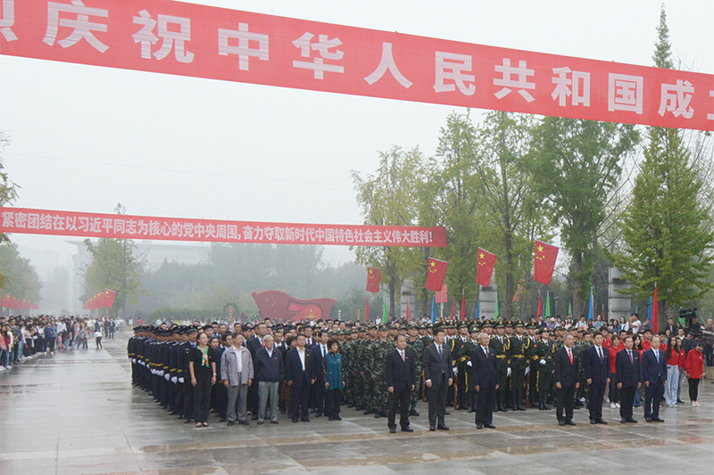
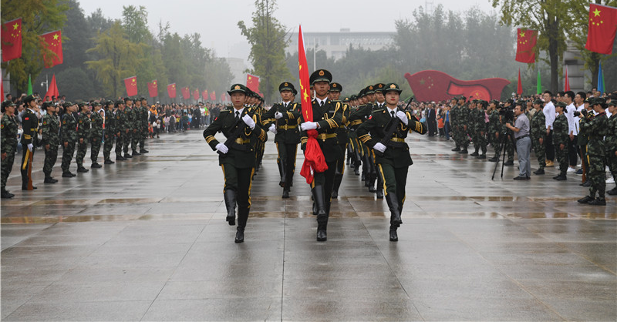
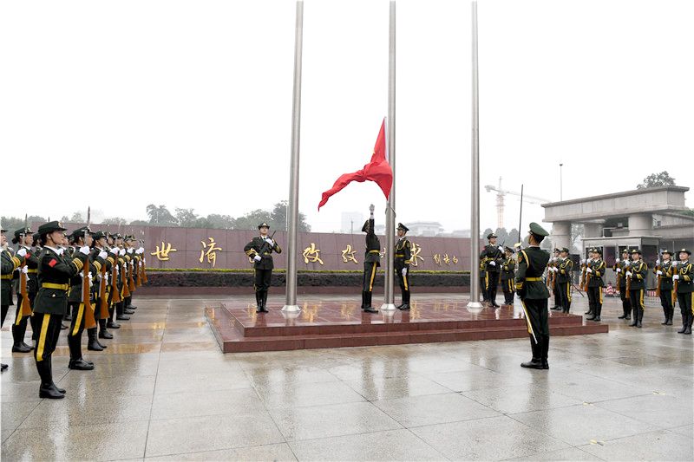
SWUFE Held Flag-Raising Ceremony to Celebrate the 70th Anniversary of the Founding of the People’s Republic of China

On 1 October 2019, teachers and students of SWUFE gathered on Liulin Campus and Guanghua Campus to celebrate the 70th anniversary of the foundation of the People’s Republic of China. Members of the SWUFE University Council, representatives of retired leaders, management team of schools and departments, representatives of teachers and students attended the flag-raising ceremony. Prof Zhao Dewu, Chairman of the SWUFE University Council, delivered a speech on Liulin Campus, and Prof Zhuo Zhi, President of SWUFE, hosted the flag-raising ceremony.

SBA Teachers and Staff Watched the Celebration of the 70th Anniversary of the Founding of The People’s Republic of China
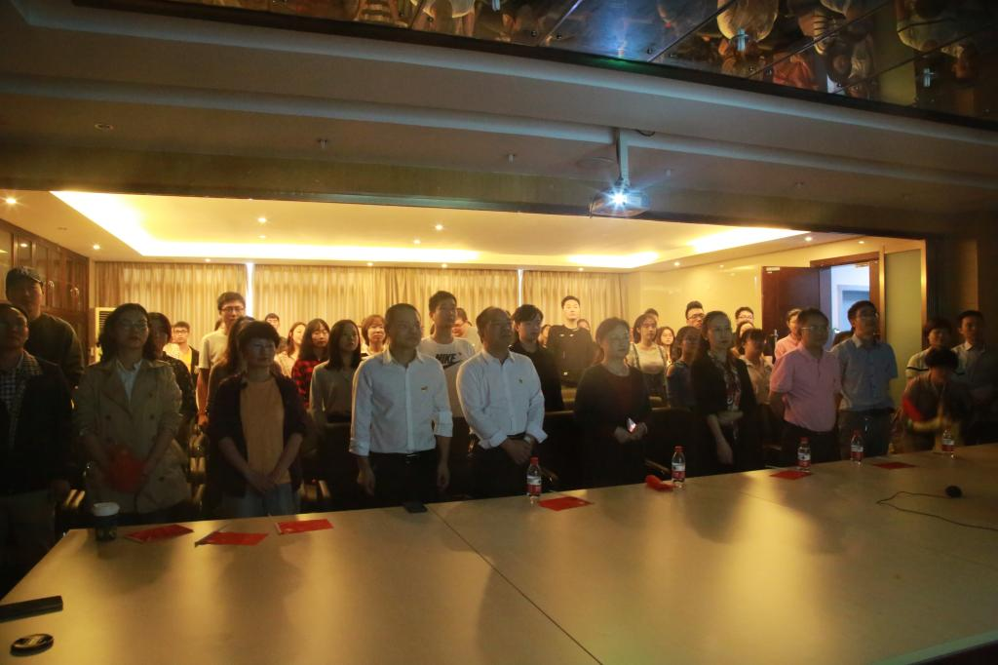
In the morning of 1 October, more than 70 representatives of the faculty and students watched the live broadcast of the celebration of the 70th Anniversary of the Founding of the People’s Republic of China in conference room A209, Tongbo building, Liulin Campus. All the teachers and students were enthusiastic and sang the national song while watching the flag-raising ceremony. Later, teachers and students actively expressed their love for China and determined to contribute to her prosperity.

Exchange Ideas of Higher Education in Chinese and French Joint Degree Programme

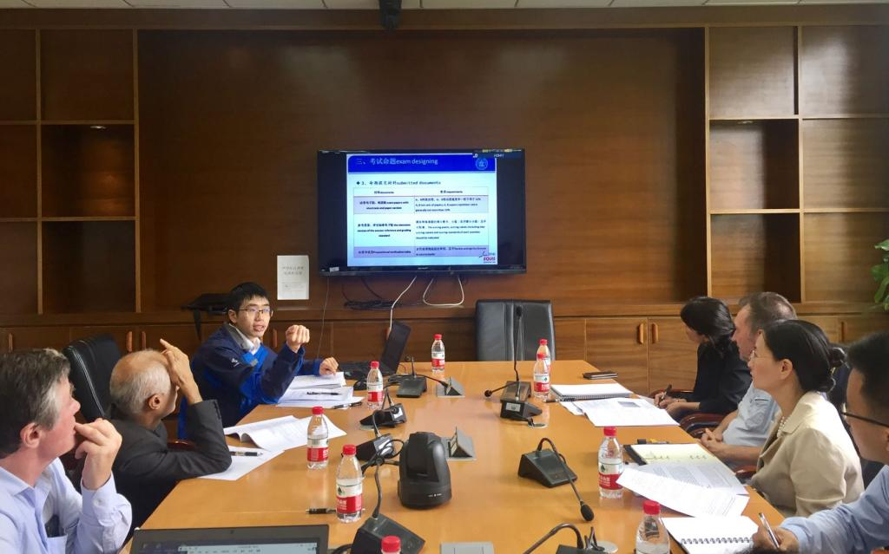
In the morning of 9 October 2019, teachers representatives and administrative staff of the SWUFE-Nantes Joint Degree Programme from both SWUFE and Nantes had a seminar on the academic affairs and management procedure. Participants exchanged their ideas and experiences on teaching and management, understood better about differences in education system of China and France, and figured out the most suitable methods for SWUFE-Nantes Joint Degree Programme, which is sufficient for the programme implementation and development.

Award Ceremony the 6th Industrial Economics Thesis Competition
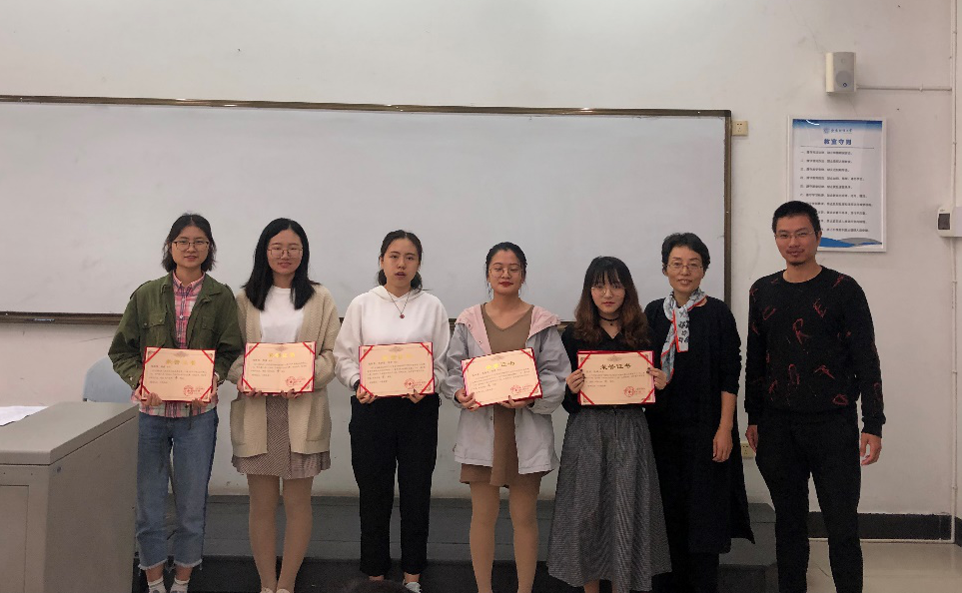
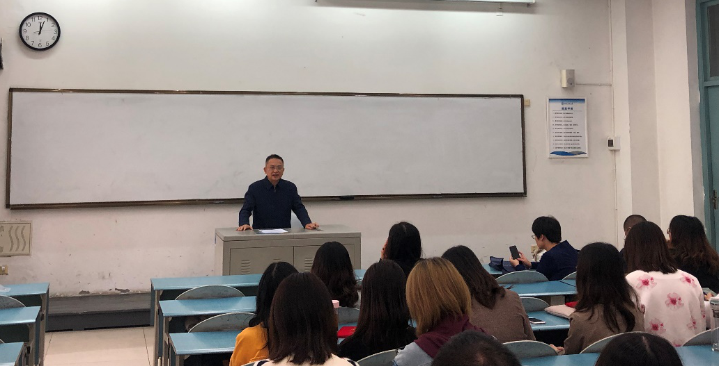
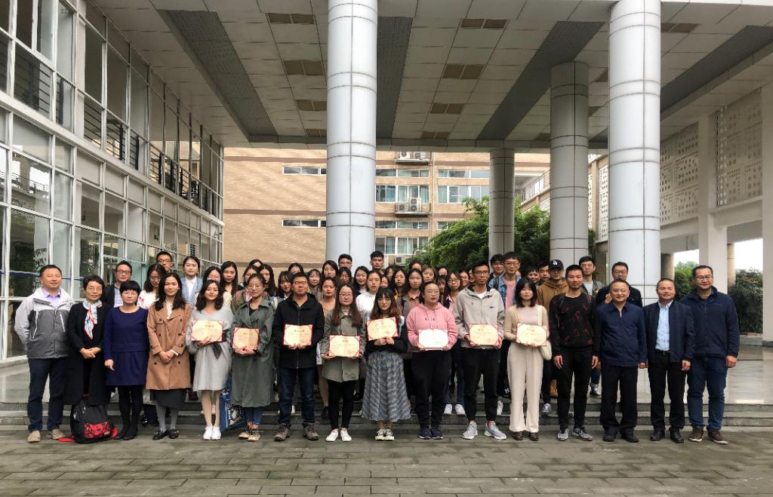
On 15 October, the award ceremony of the 6th Industrial Economics Thesis Competition was held in H101, Yide building, Liulin campus by SBA Institute of Industrial Economy. Teachers from the institute and more than 70 undergraduates and postgraduates attended.
Competition papers were from 11 schools and institutes, like School of Business Administration, School of International Business, Research Institutes and Economics and Management, School of Finance, etc. All papers were reviewed fairly by 6 experts, among which 16 papers won the prize. The competition helps students to learn the real economy and improve research interests and abilities. The Institute of Industrial Economy is aiming at providing a platform of competition, study, communication and friendship, and educating more talents in industrial economics for China.

Practical Teaching Activity of Transportation Organization and Management Course: Visit to China Tobacco Sichuan Industrial Co., Ltd.

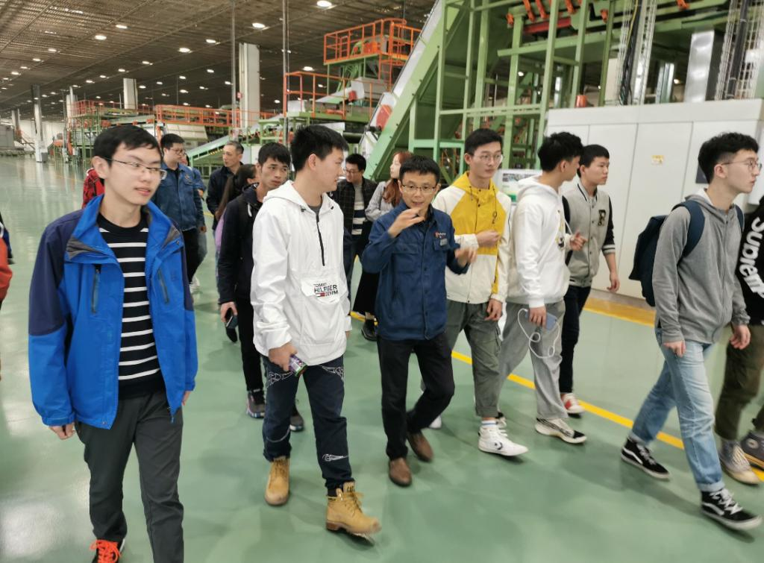
On 22 October 2019, Prof Liang Zhijie, professor of Transportation Organization and Management course, led juniors majoring in Logistics Management to visit the factory of China Tobacco Sichuan Industrial Co., Ltd. in Chengdu to help students know more about the enterprises and to combine theory with practice. Introduced by the company staff, students learnt the intelligence and process standardization of modern warehouses, and increased their interests and understanding of logistics management.

The 7th Female Entrepreneurs Programme Opened Classes and 96 Female Entrepreneurs Bloom "Her Power"
During 24-27 October 2019, 96 outstanding female entrepreneurs from all over China started a brand new learning journey in SWUFE. They are enrolled in the 7th Jiaxin Female Entrepreneurs Programme and will receive free professional trainings in business, management, and marketing fields in 8 months.
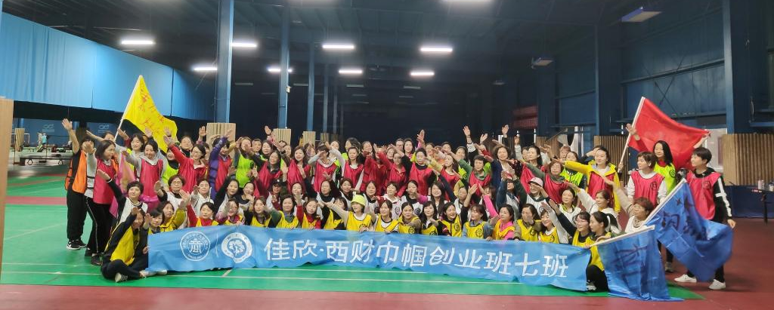
The “Female Entrepreneurs Programme” is a
non-profit public welfare progrmme held by School of Business Administration (SBA) at Southwestern University of Finance and Economics (SWUFE), aiming at improving the business thinking and knowledge of management of female entrepreneurs, and helping them develop their companies and gain their happiness. It is a practice that SWUFE and SBA are fulfilling the social responsibility.

International Students Visited Panda Base
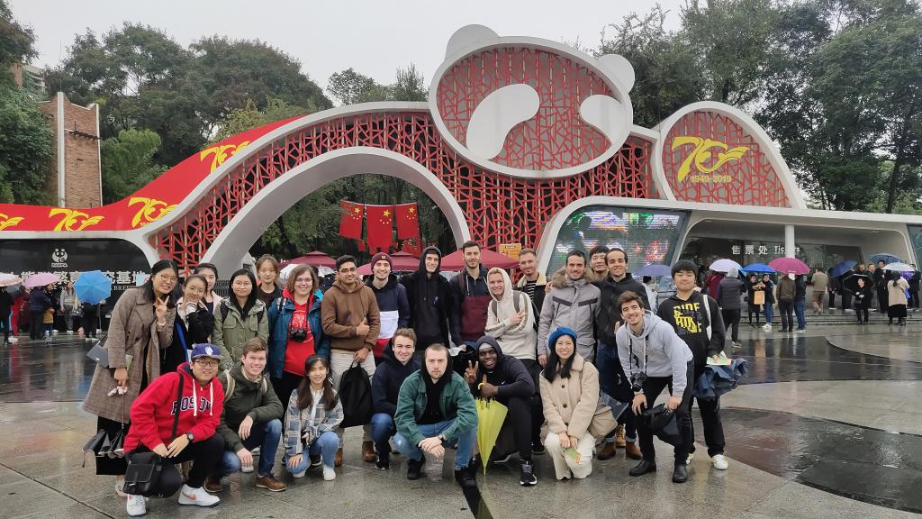
In the morning of 26 October, the International Affairs Office of SBA organized international students to visit Panda Base. Some volunteers of the International Students Association (ISA) accompanied the international students to visit the hometown of pandas. During the visit, volunteers introduced pandas to international students, and international students shared their experiences of studying and living in China, describing the cultural differences between China and the west. During the conversation, student got to know each other better and had a deeper friendship.

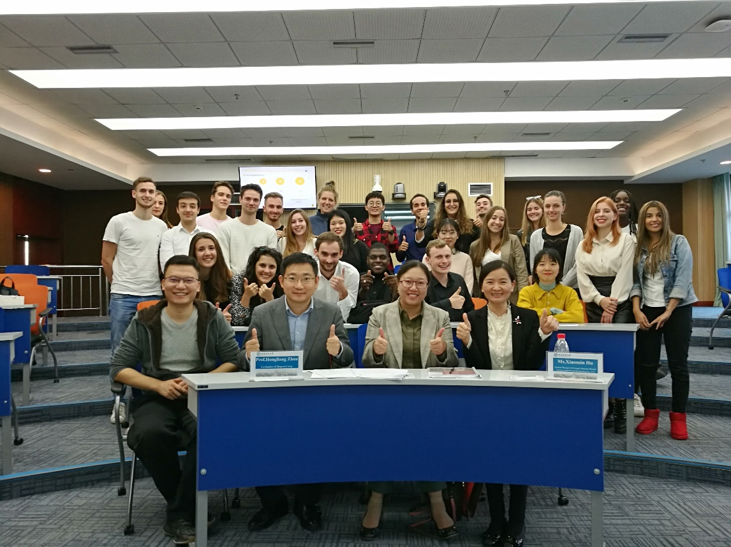
Exploring Innovation Management in Business Plan Seminar
In the afternoon of 28 October, the International Affairs Office of SBA held a business plan seminar for more than 30 international students in J303, Gezhi Building, Liulin campus. The judges were Mr Zhou Hongliang, CEO of Chengdu Jingwei Technology Co., Ltd., Ms Hu Xiaomin, General Manager of Chengdu Jingyingzhiyuan Venture Capital Management Co., Ltd., Professor Tang Mingfeng Tang and Associate Professor Ma Jiangshui from SBA.
Four groups of international students presented their well planned and unique innovative business plans. In Q&A session, students benefited a lot from the judges’ comments. This seminar stimulated international students to understand the innovation management spirit and to apply theories to practice. It was an exercise of public speech of students and strength of cooperation among them.

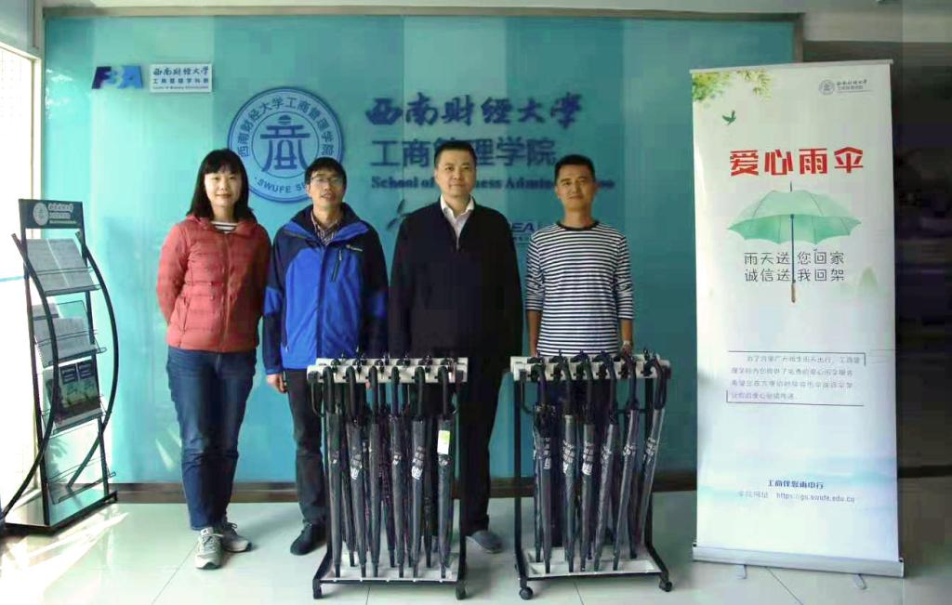
Free Shared Umbrellas were Provided
On 28 October, Prof Kou Gang attended the launching ceremony of free shared umbrellas in the lobby of Tongbo Building A held by SBA. There are 24 umbrellas in the lobby provided to students and teachers freely and maintained regularly. It is a way of passing love and civilization, warming students and teachers in rainy season.

SBA International Students Participated in 2019 SWUFE Sports Meeting
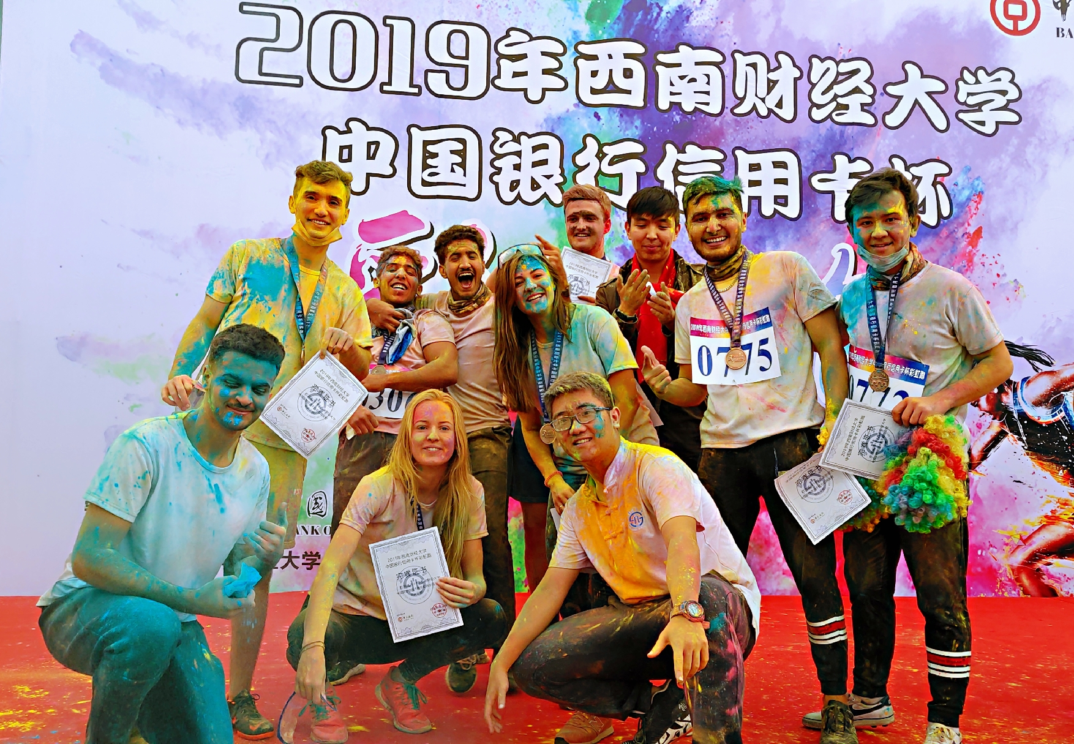
The 2019 SWUFE Sports Meeting was held from on 31 October and 1 November on Liulin Campus. Its theme was to “celebrate the National Day, stay young, show vitality, and keep health". International students from the School of Business Administration actively participated in different kinds of competitions, including the shot put, high jump, long jump, track and field, tennis, badminton, rainbow running etc. Among them, Florian Küttler from Germany won the second prize in shot put and the third prize in high jump. It is good chance to play games with local students, to demonstrate themselves and to enrich their campus life.
