INDEX
- Basketball Contest “Gong Shang Cup” Struck a Successful End----- 1
- SWUFE Journal Financial Innovation was Included in the Recommendation List of China’s High Quality Journals in Science&Management by FMS-----2
- SWUFE Students Gain Great Results in Contemporary Undergraduate Mathematical Contest in Modeling----3
- The Society of Consumer Economics Won the Key Award and Subsidy of Excellent Social Science Academic Association of National Social Science Fund-----4
- The Final of 2020 ISWUFE Internationalization University Students Entrepreneurial Plan Competition was Held Successfully----5
- Students from SWUFE-Audencia BBA Programme Visited Decathlon Branches and Ubisoft

International Affairs Office and Sino-French Innovation Research Center
School of Business Administration
Southwestern University of Finance and Economics

December 2020

Basketball Contest “SBA Cup” Struck a Successful End
On the afternoon of November 28th , the final of 2020 "SBA Cup" basketball contest was successfully held in Guanghua gymnasium. The competition is among representatives composed of graduate and undergraduate students. After two weeks of fierce competition, the "Big Four" team from Grade 4 won the men's basketball championship, and the "Sunshine Team" from Grade 3 won the women's basketball championship.
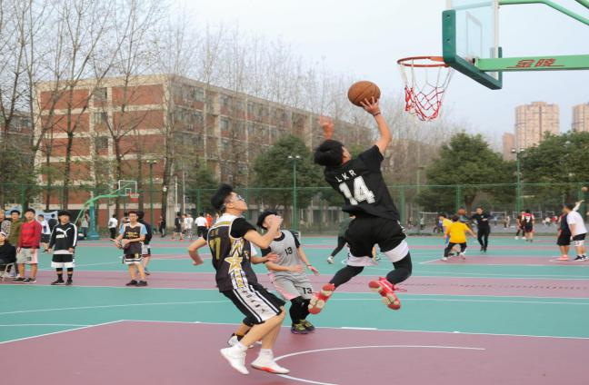
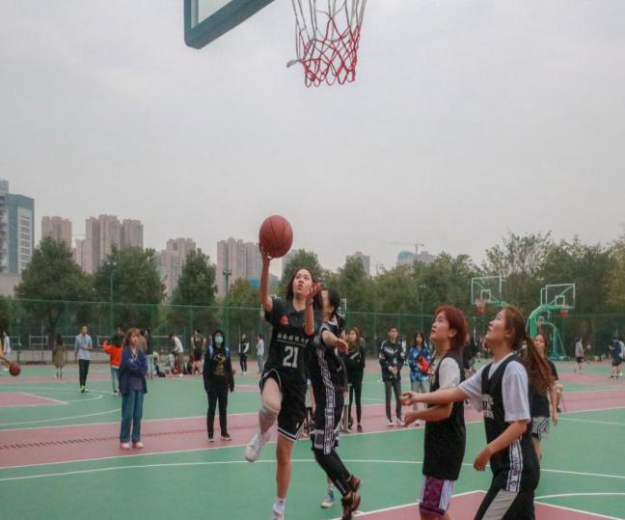
"SBA Cup" basketball contest is a traditionally-held sports event of SBA, which aims to cultivate and carry forward the sports spirit and promote the all-round development of young students. The competition is divided into men's basketball 5v5 and women's basketball 3v3, in which a total of 17 teams signed up for the competition. In the men's basketball final, the two sides maintained a good competitive state. The precise throwing, smooth layup and clever cooperation all showed the spirit of SBA students going to all lengths and dare to forge ahead. In the end, team "Big Four" won the contest with a score of 50-40. The final of the women's basketball team was also wonderful. The students actively fought for it, and the scores were too close to differentiate. Finally, team "Sunshine" won by a weak advantage of 16-15. The athletes' spirit of fighting bravely on the field infected everyone presented. They expressed their love for sports and life with their passion and sweat, and showed the team spirit of fraternity, mutual assistance and youth.
6

SWUFE Journal Financial Innovation was Included in the Recommendation List of China’s High Quality Journals in Science&Management by FMS
In December, 2020. According to the “List of China’s High Quality Journals in Science &Management”, i.e., the FMS List of China’s High Quality Journals in Science &Management, (FMS is abbreviated for Federation of Management Societies of China), which is jointly released by Chinese Society for Optimization, Overall Planning and Economic Mathematics, Society of Management Science of China, and Systems Engineering of China, SWUFE journal Financial Innovation was included as the high quality international FMS journal.
Financial Innovation was founded in the year of 2015, whose focus is on novel financial tools, financial techniques, and research on financial products. Financial Innovation aims to provide an internationalized platform for academic exchange of the cutting-edge research in finance under the background of e-commerce age. Currently, Financial Innovation was included in several reputable databases, such as SSCI, Scopus, DOAJ, ProQuest, Google Scholar, etc. In 2020, its impact factor reaches 2.964, ranking the 14th in the field of Business and Finance among all the 108 journals included by SSCI, which is in the Q1 section globally. This marks that SWUFE has a fruitful achievement in leading “Novel Finance” and escalating the academic impact in financial area.

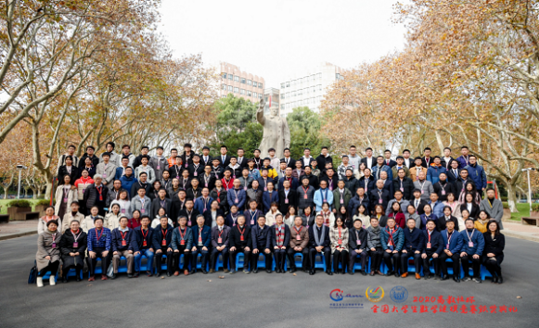
SWUFE Students Gain Great Results in Contemporary Undergraduate Mathematical Contest in Modeling

Recently, according to the list of awards of National Undergraduates Mathematical Contest in Modelling, delegates from SWUFE achieved excellent result in this competition, among which 1 team got the national-level meritorious winner, 8 delegate teams were awarded the national-level honorable mention, and 41, 33, and 4 delegate teams got provincial-level first prize, provincial-level second prize, and provincial-level third prize respectively.
The Contemporary Undergraduate Mathematical Contest in Modeling for is a mass scientific and technological activity held by China Society of Industry and Applied Mathematics. The competition was founded in 1992 and held once a year. It is one of the first 19 competitions to be included in the “Ranking List of Advanced Discipline Competitions”. In 2020, 1470 universities / campuses, 45680 delegates (41826 undergraduates and 3854 junior college students) from the whole country, the United States, the United Kingdom and Malaysia, and more than 130000 people signed up for the competition.
In all, 169 delegate teams and 470 students from SWUFE participated in the competition. 9 teachers from the Institute of Mathematical Modeling, School of Economics and Mathematics, are responsible for the organization, selection, training, guidance and other related work. During the challenging period of COVID-19 epidemic, the instructors overcame all kinds of difficulties and effectively guided the students to study independently and cultivated the spirit of cooperation and innovation ability by means of popularization and motivation, online teaching, online communication and extracurricular practice.

The Society of Consumer Economics Won the Key Award and Subsidy of Excellent Social Science Academic Association of National Social Science Fund

According to the latest notice of the Social Science Office of the Publicity Department of the Communist Party of China, the Society of Consumer Economics won the title of "Excellent Social Science Academic Association of the National Social Science Fund" in 2020 and won key awards and subsidies. It is reported that the Social Science Office of the Publicity Department of the Communist Party of China and the National Social Science Foundation have selected more than 150 "Key Contact National Social Science Academic Associations" in the preliminary stage, and after strict evaluation and scoring by third-party institutions, the list of awards and subsidies for outstanding social science academic associations of the National Social Science Fund in 2020 was released. Only 50 social science academic associations in China was awarded. In May 2020, Consumer Economics was determined by the National Social Science Fund and the Ministry of Education as "the Key Contact with the National Social Science Academic Community". In September 2020, the National Symposium on the theory and practice of Consumer Economy and the research on the Development of Emerging Consumer Power in an all-round well-off era, which are the theme academic activities of the social science academic association of the National Social Science Foundation, have both been approved by the National Office of Philosophy and Social Sciences.
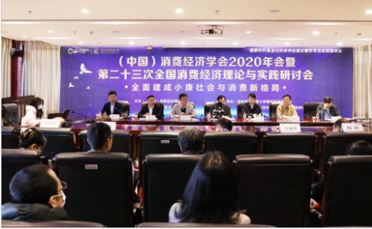

The Final of 2020 ISWUFE Internationalization University Students Entrepreneurial Plan Competition was Held Successfully
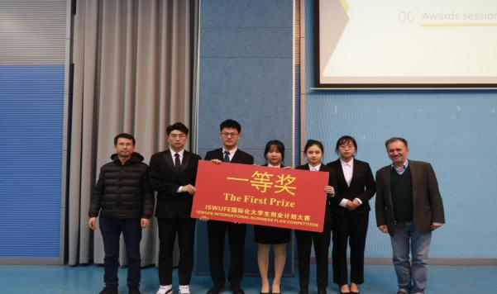
On the afternoon of December 8th , the final of the 12th ISWUFE Internationalization University Students Entrepreneurship Plan Competition was successfully held in the student activity center. Professors from School of Business Administration and Audencia Business School presented as the members on a review committee.
This competition aims to build an international innovation and provide exchange platform for entrepreneurship, and is committed to cultivating students' professional quality and improving their ability to practice what they have learned. In the forthcoming work and study, our school will always adhere to the mission of "Integrating Chinese and foreign management wisdom, based on local practice, innovating applied research, and cultivating competitive management talents". We will continue to stimulate the young students' innovative and practical qualities, help them forge ahead in the wave of innovation and entrepreneurship, and be "trendsetters" in the new era!
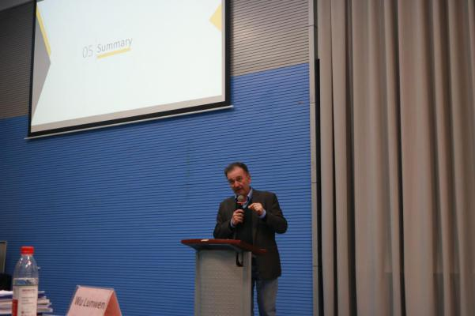
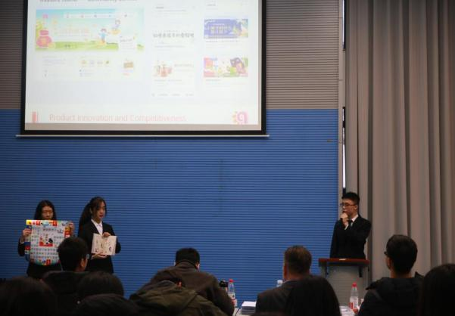

Students from SWUFE-Audencia BBA Programme Visited Decathlon Branches and Ubisoft

On the afternoon of December 1st, Dominique, Director of Audencia Business School led the Grade 3 students of SWUFE-Audencia BBA Programme to visit Decathlon Chengdu Tianfu Retail Store and Ubisoft Chengdu Studio for practical exchange. This aims to help students understand the actual application and implementation of marketing strategies in different industries and to cultivate students' ability of integrating theory with practice. The students' visit ended with a good harvest. The two companies have different styles. Decathlon is energetic and confident, and Ubisoft is rigorous and meticulous. Its unique corporate culture and values may be one of the reasons why Decathlon has grown into a towering tree in their respective fields. Back to Liulin campus, it is almost nightfall, but the students' faces are rarely tired. On the way back, the students have been discussing what they have seen and heard about the two companies. The operation, management and marketing mode of international enterprises has benefited students a lot.
