INDEX
1. Warm care for returned students——Leaders of the School of Business Administration visit the students’ dormitory 1
2. The Fifth Dialogue with Corporate Executives Held Successfully 2
3. Seminar for Graduates of the School of Business Administration was successfully held 3
4. Outstanding alumni entrepreneur Jiang Shiqiang gave a special lecture for graduates 5
5. Student Representatives Shared Their Experience on Applying Graduates of Foreign Universities 6

International Affairs Office and Sino-French Innovation Research Center
School of Business Administration
Southwestern University of Finance and Economics

June 2020

Warm care for returned students——Leaders of the School of Business Administration visit the students’ dormitory
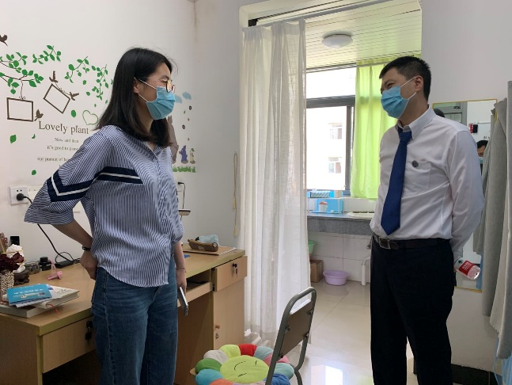
In the afternoon of June 3, leaders of the SBA went to the students' dormitory to visit the students who just returned to school, and sent the students sincere care and warm greetings from the school and college.
The four leaders went separately to some dormitories in Zhizhi Yuan, Duxing Yuan, Cheng Yuan, and Zhi Yuan to have a deep communication with students, conveyed the care and greetings of the school leaders and teachers of SBA to each student. And the leaders highlighted again the signification of returning to school and restarting classes, and the students expressed their support and understanding of the school’s work. During the visit, the leaders found that most of the students have right cognition for epidemic prevention and were able to do all kinds of prevention and control measures, and have adapted to the teaching and management methods adopted by the school during the epidemic prevention period. However, it has also been found that some students lack of awareness of epidemic prevention and control, they closed the doors and windows of the dormitory, so that the air can not circulate. In this regard, the four leaders reiterated to the students that during this period, they must adhere to the basic epidemic prevention requirements of “washing hands, wearing mask, and keep one-meter distance”. They also need to pay attention to “more ventilation, no chatting, and a better mood” every day, encourage students to enhance physical exercise, make a good time management, and communicate with teachers in time if they have any difficulties.
1
Students have expressed that they must remain alert before the end of the epidemic, study the "Learning Materials for COVID-19 Prevention and Control" prepared by SBA for students, and implement the prevention and control measures in strict accordance with the requirements of the school. On the day of the 95th anniversary of the school, the students also expressed their great cherishment of the opportunity to return to school. They will wait for the arrival of the new semester with a good state and keep healthy for fighting against the COVID-19. As a youngster in the new era and a SWUFEer, we should struggle for the common destiny of the school and the nation!

The Fifth Dialogue with Corporate Executives Held Successfully
On the noon of June 4th , 2020, the fifth Dialogue with Corporate Executives hosted by the Sino-French Innovation Research Center and Nantes Project Office of the School of Business Administration of Southwestern University of Finance and Economics held successfully online. Themed as financial management in supply chain, the lecture was given by Mr. Frank Stefan Gottwald, CFO of Siemens Electronic Factory Erlangen, Germany.
Frank Stefan Gottwald pointed out that within the digital transformation of the Supply Chain, tremendous changes are brought into the industrial manufacturing processes: speed, flexibility, quality and efficiency. Yet this transformation process in production that requires significant investment in capital and human resources would subsequently increase costs. Hence the topic is mainly about how to balance costs and efficiency. Mr. Gottwald mentioned, “It is necessary to establish a sophisticated and well-balanced set of financial Key Performance Indicators (KPI’s) to measure the cost development in the production and obtain the required transparency”. Working for many years as CFO of various factories of Siemens, he presented how this financial KPI set in the factories is designed and which conclusion can be taken by the Management.
2
The novel coronavirus can’t stop SWUFE students from progressing, nor does time difference. The speaker and audiences are so concentrated despite the early morning in Germany and noon in China. As the last lecture of this semester, “Dialogue with Corporate Executives” lecture series obtain popular recognition and attract a growing number of students, providing a great platform of studying and communication under the special circumstance of pandemic.

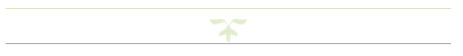

Seminar for Graduates of the School of Business Administration was successfully held

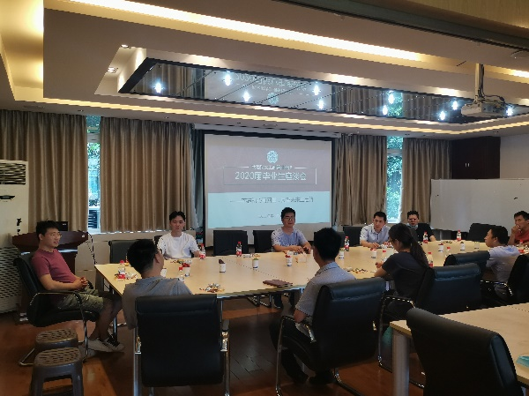
In order to further improve the education of graduates, accurately understand the ideological dynamics of graduates before leaving school, and strengthen the emotional connection between graduates and the SBA, on the afternoon of June 10, a seminar for graduates of the SBA was successfully held, and SBA graduate instructors, teaching officers and graduate representatives participated.
At the meeting, the students spoke freely and the atmosphere was lively. They put forward a lot of pertinent opinions and reasonable suggestions about the teaching management services of SBA.
Finally, the teachers of the college thanked the students for their understanding, support and cooperation
in the management of teaching affairs in SBA. They hoped that the students would be practical, pursue excellence, realize their dreams as soon as possible and achieve better progress in the future.
3

Outstanding alumni entrepreneur Jiang Shiqiang gave a special lecture for graduates

On the afternoon of June 9, 2020, Jiang Shiqiang, an outstanding alumnus, an entrepreneur and chairman of Sichuan Deyuan Oil and Gas Engineering Co., Ltd., gave a lecture named “Stick to the same in change—Reflections on the process of starting a business” for the graduates of SAB at 105 Hongyuan Building, Liulin Campus. The lecture was chaired by Professor Zhang Yu.
Taking his own experience as an example, Alumnus Jiang Shiqiang talked about the experience in entrepreneurship: how to overcome difficulties, solve problems, and make decisions at the important stage in life. Mr. Jiang Shiqiang emphasized that cross-professional thinking is very important. He hopes that students will learn to solve practical problems with the knowledge of other majors after they begin to work, and they will face all difficulties with a positive attitude.
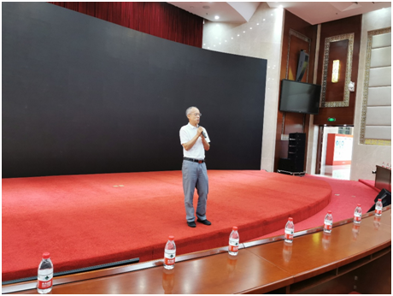
Every step counts in one’s life. Mr. Jiang’s lecture inspired the students to work hard. They gained a lot from the lecture and it pointed out the direction for their future study and work.

4

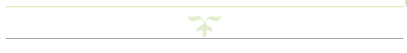
Student Representatives Shared Their Experience on Applying Graduates of Foreign Universities
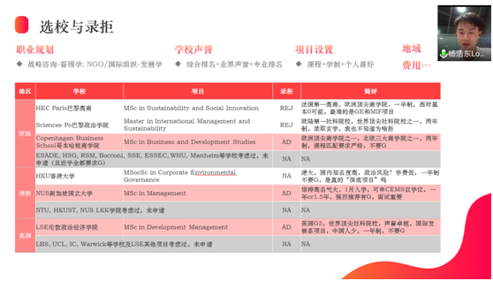

On the evening of June 17, 2020, the session on sharing experience of applying foreign universities graduates was successfully held in the form of an online lecture by SWUFE-Audencia BBA Program Office of SBA. Excellent students who have successfully applied for master's degree in famous foreign universities were invited to share their application experience for BBA students. The first meeting was successfully held on June 11.
From the mid-June of each year, students would begin to prepare for applying to foreign universities. In 2020, class of 2017 will soon apply for their ideal schools. The BBA Program Office selected 6 students who were admitted to famous universities such as London Business School, London School of Economics and Political Science, National University of Singapore, Columbia University, etc. to explain the basic requirements, school selection, application and personal suggestions for students who want to study abroad.
Combining personal experience, several speakers summed up the factors that should be considered when choosing overseas universities, and then shared their application journey. From repeated rejections, no news, gap year, to the final success, such a situation is very normal for every applicant. Each of speakers has a different focus, yet what they mentioned most was ‘knowing yourself, figuring out what you want’. Only by obeying the inner voice can you get enough motivation, this might be an important reason why they can successfully apply for master's degree.
5
In the Q&A part, the students asked questions and exchanged contact information with these keynote speakers. After the sharing meeting, the BBA students also spontaneously established a study abroad exchange chat group, providing a platform for information sharing.

6

