NEWSLETTER

SBA SWUFE

Index
The 2019 "SBA Cup" Teacher-Student Basketball Match Grandly Held 1
Workshop of Belgian Comics “Boule & Bill” in SWUFE —— 60th Anniversary Celebration 1
The SWUFE Alumni Association in Germany was established in Berlin 2
Mr. Guillaume Blaess from Audencia Business School visited SBA 4
Delegation of SWUFE visited universities in Asia and Europe 4
The 2020 SBA Chinese and International Students New Year Party had come to a success 5
SBA Held Pre-trip Training of Spring Study Abroad-Exchange Program of 2020 6

International Affairs Office and Sino-French Innovation Research Center
School of Business Administration
Southwestern University of Finance and Economics

December 2019

NEWSLETTER

The 2019 "SBA Cup" Teacher-Student Basketball Match Grandly Held

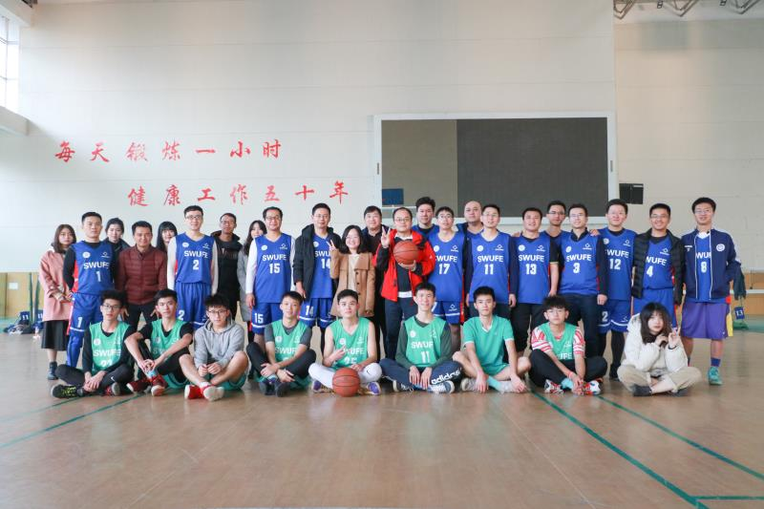
In the afternoon of 3 December 2019, the 2019 "SBA Cup" teacher-student basketball match was grandly held in Guanghua gymnasium. Teachers and students in School of Business Administration (SBA) actively participated and had a fierce competition. Finally, the teacher team won the champion with a score of 104:102.
At the beginning of the match, teachers relied on their tacit cooperation and superb skills to control the ball, and won the applause of the audience with a three-pointer. Immediately after, the two teams engaged in a fierce duel and the scores rose stubbornly with wonderful dribbles, layups and steals. The continued shouting cheers brought the match to a climax. Subsequently, the teacher team scored two more points by virtue of a jump shot, winning the championship of this match. In the end, the two teams shook hands with each other to show the friendship. The "SBA Cup" teacher-student basketball match came to a successful conclusion.
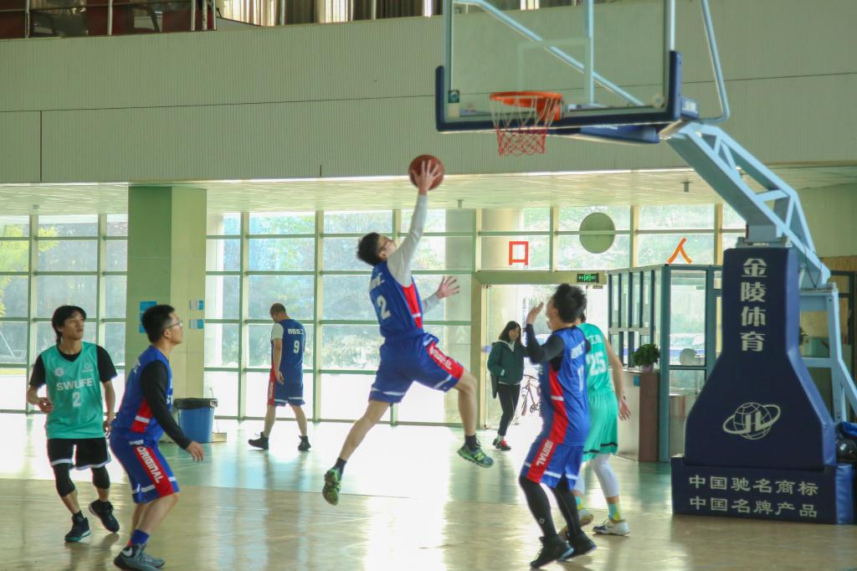
The 2019 "SBA Cup" teacher-student basketball match adheres to the purpose of "friendship first" by promoting exchanges and friendships between teachers and students through sport competition. At the same time, it demonstrated the firm determination of SBA to respond positively to the deepening education reform and improving students’ comprehensive quality.

Workshop of Belgian Comics “Boule & Bill” in SWUFE

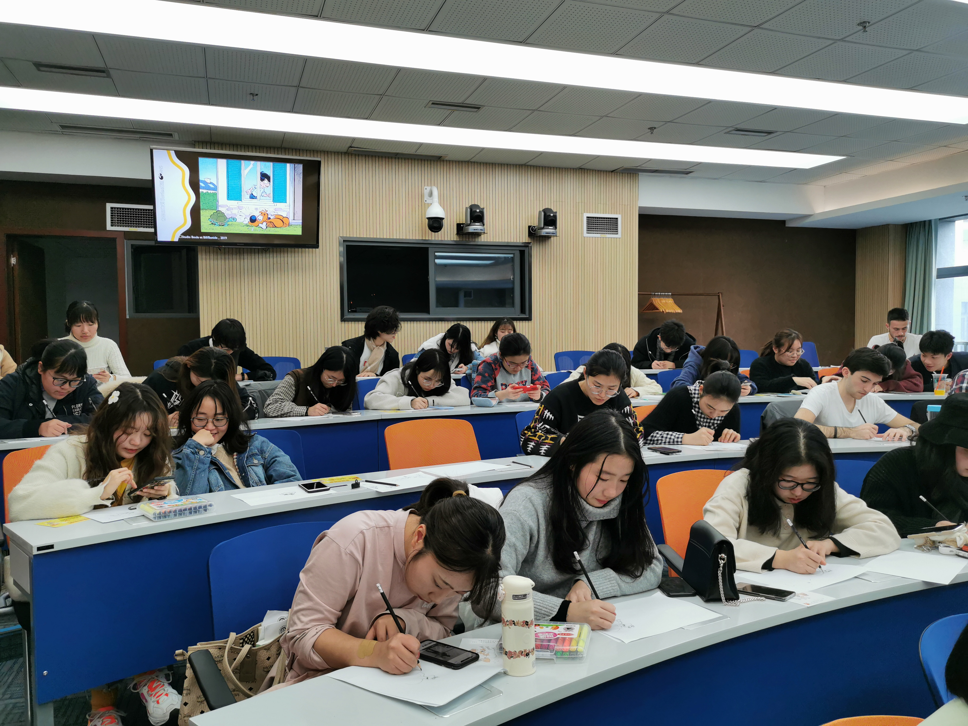
——60th Anniversary Celebration
On 6 December 2019, the International Affairs Office and the Sino-French Innovation Research Center of School of Business Administration (SBA) and the French Alliance of Chengdu jointly host a workshop of Belgian comics which called “Boule & Bill” in order to celebrate its 60th anniversary. The chief cartoonist of “Boule & Bill”, Mr. Jean Bastide from France and the president of the French Alliance of Chengdu, Mr. Gildas Lusteau participated in the workshop.
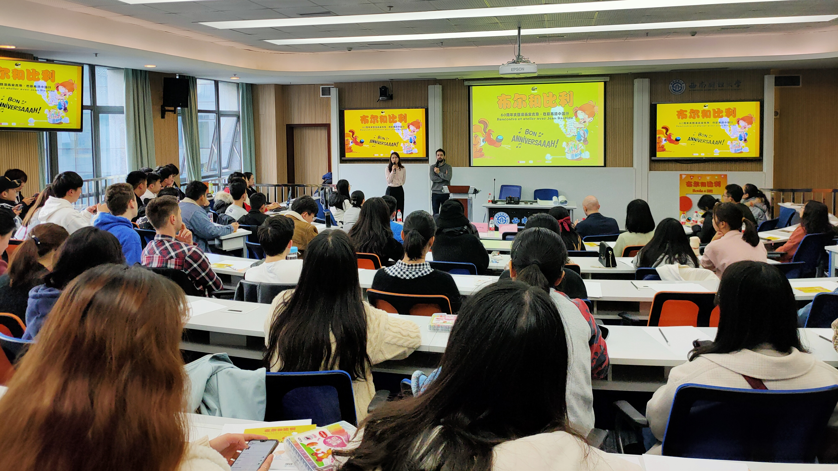
Prof Tang Mingfeng, Director of the International Affairs Office and the Sino-French Innovation Research Center of SBA, extended a warm welcome to Mr. Jean Bastide and expressed her heartfelt thanks to the support of the French Alliance of Chengdu.
Mr. Jean Bastide showed his happiness for visiting SWUFE and introduced the history of “Boule & Bill”. As a professional cartoonist, Bastide spends eight hours per day for creating and accumulating inspiration. From his point of view, the professional knowledge is more important than interest. During the workshop, he explained to the students how to draw the turtle of “Boule & Bill” and interacted with them by using Chinese to praise their excellent performances. In the end, Bastide said that he would consider creating the story of “Boule & Bill” in China in the future.
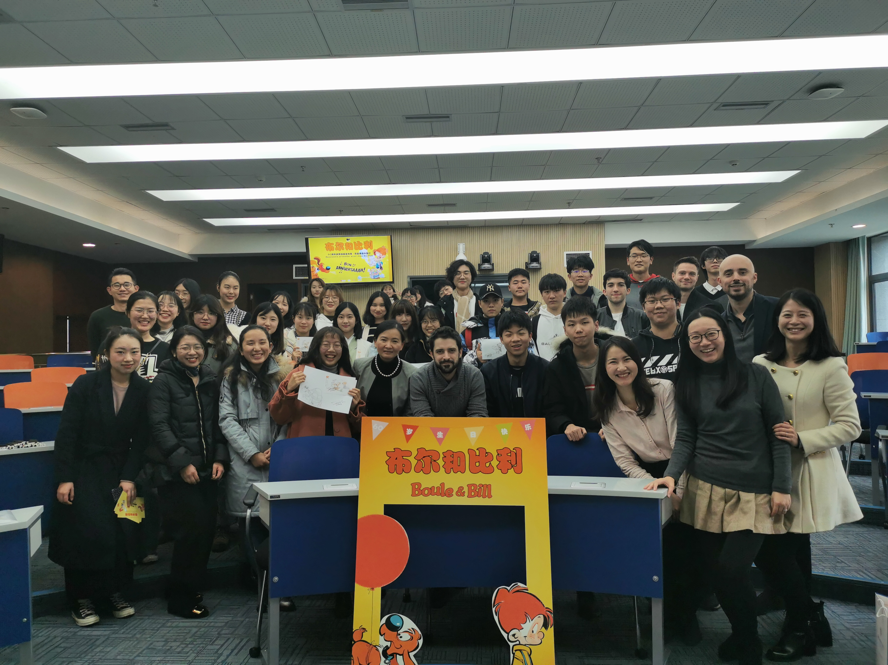
Finally, Mr. Gildas Lusteau expressed his appreciation of SBA’s invitation and students’ participation. He said that the French Alliance of Chengdu has always been committed to promoting and disseminating French culture.

The SWUFE Alumni Association in Germany was established in Berlin

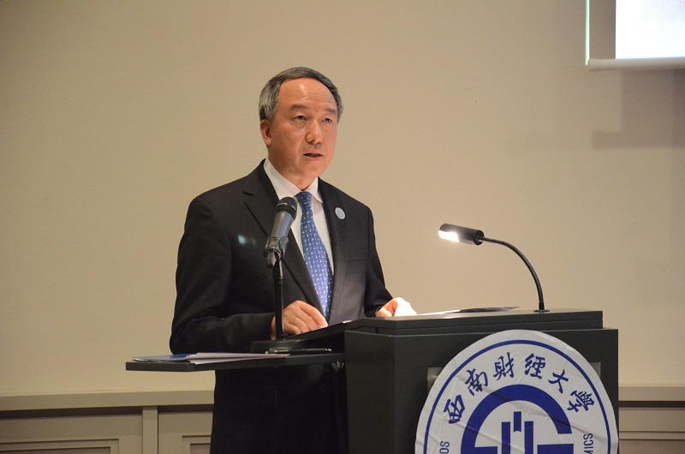
On 10 December 2019, the Ceremony of Establishment of SWUFE Alumni Association in Germany was successfully held in Berlin, Germany. Prof Zhuo Zhi, the President and Deputy Party Secretary of Southwestern University of Finance and Economics (SWUFE) and other more than 50 Chinese and International representatives attended the ceremony. Prof Zhuo Zhi made a speech on the ceremony. The Chinese Embassy in Germany congratulated the congress on the establishment.
The ceremony began with the solemn national anthems of China and Germany. Prof Zhuo Zhi expressed warm congratulations on the establishment of the Alumni Association in Germany and thanked all the presented guests and alumni. He pointed out that SWUFE attaches great importance to the opening up of education and made gratifying achievements in various fields of international exchanges and cooperation in recent years. The choice to establish the Germany Alumni Association in Berlin is a summary and sublimation of the exchanges between SWUFE and Germany. Prof Zhuo Zhi hoped that the German Alumni Association could base on Germany and face to Europe to serve the development of alumni and Alma Mater.
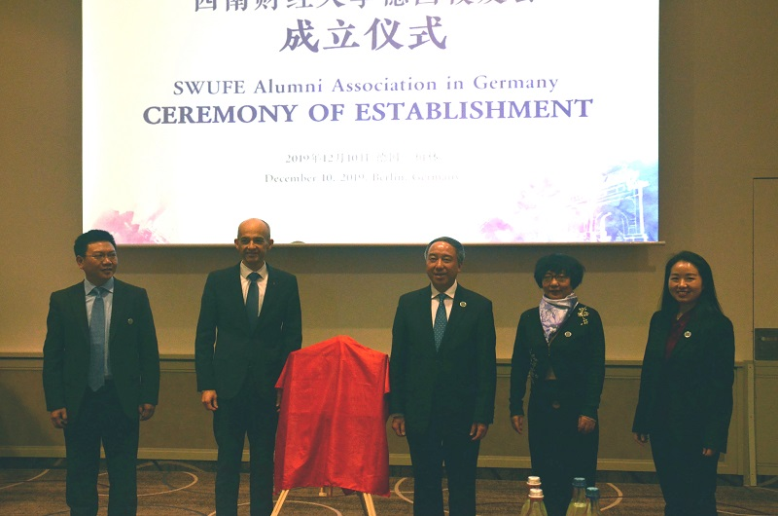
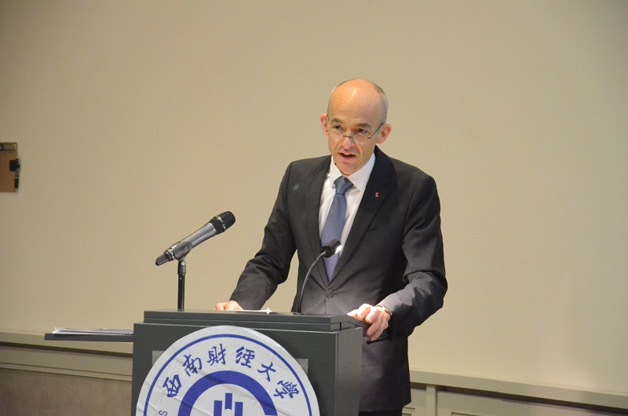
Andreas Zaby, the President of SWUFE friendly cooperative institution —— Berlin School of Economics and Law (BSEL), was invited to the ceremony and delivered a speech. Zaby spoke highly of the profound friendship between SWUFE and BSEL during the 32-year cooperation and expressed enthusiastic congratulations on the establishment of the SWUFE Alumni Association in Germany.
During the ceremony, the participants watched the video of SWUFE and the China-Germany "Cooperation · Look Back". Marko Rukavina, the General Secretary of the first secretariat of German Alumni Association, delivered her inaugural speech. Prof Zhuo zhi and Zaby jointly inaugurated the German Alumni Association. Finally, the ceremony ended successfully in the anthem of SWUFE.
For a long time, SWUFE has carried out all-round, multi-level and wide-ranging cooperation with German universities and institutions, and cultivated a large number of outstanding German alumni. The SWUFE Alumni Association in Germany is the first SWUFE overseas alumni association in Europe, following those in North America, Thailand and Singapore. It aims to carry forward the SWUFE spirit of "Benefiting the people from the world", gather the strength of Chinese and German alumni, help the development of Alma mater, and continue to promote the friendship between the two countries.

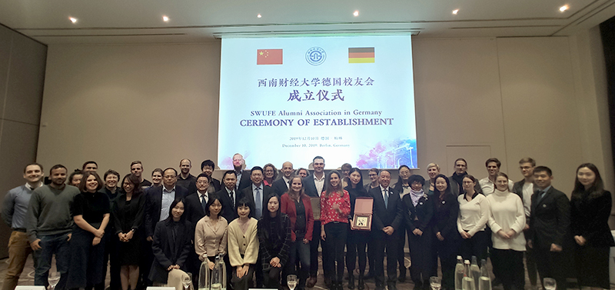

Mr. Guillaume Blaess from Audencia Business School visited SBA
On 11 December 2019, Mr. Guillaume Blaess, Deputy Director of the International Exchange Office of Audencia Business School (ABS) in France, visited School of Business Administration (SBA) to keep abreast of recent developments of SWUFE-Nantes Joint Degree Programme.
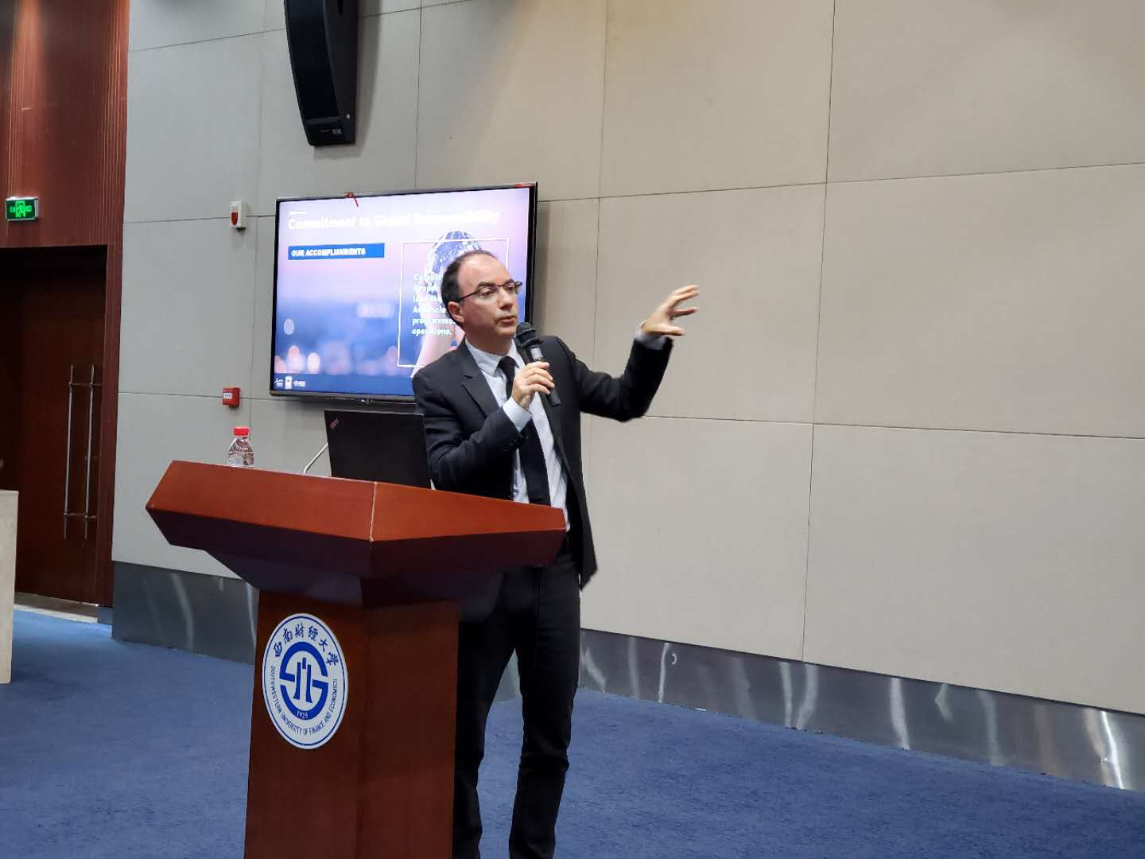
In the morning, Prof Tang Mingfeng, Director of SWUFE-Nantes Joint Degree Programme, Mr. Dominique Dubois, Academic Director of ABS and Mr. Guillaume Blaess met more than 120 students who are enrolled in this programme. Blaess gave a general introduction of the geographical location, historical development, academic level, school characteristics, programme advantages, etc. of ABS. During the Q&A phase, students asked questions about study, internship and career in France and received patient and comprehensive explanations from Blaess.
Later, Prof Kou Gang, the Executive Dean of SBA and other representatives of SBA met with Mr. Guillaume Blaess. The two sides had effective communication on current status and future developments of the programme, and reached agreements on French faculties, summer course, graduation thesis and internship employment. During this visit, Mr. Guillaume Blaess also had a talk with 11 students who are going to exchange in ABS in 2020 spring.
The visit of Mr. Guillaume BLAESS has achieved significant results. It is believed that with the joint efforts of both sides, the SWUFE-Nantes Joint Degree Programme will become a unique high-quality Chinese-Foreign Joint Programme in China.

Delegation of SWUFE visited universities in Asia and Europe
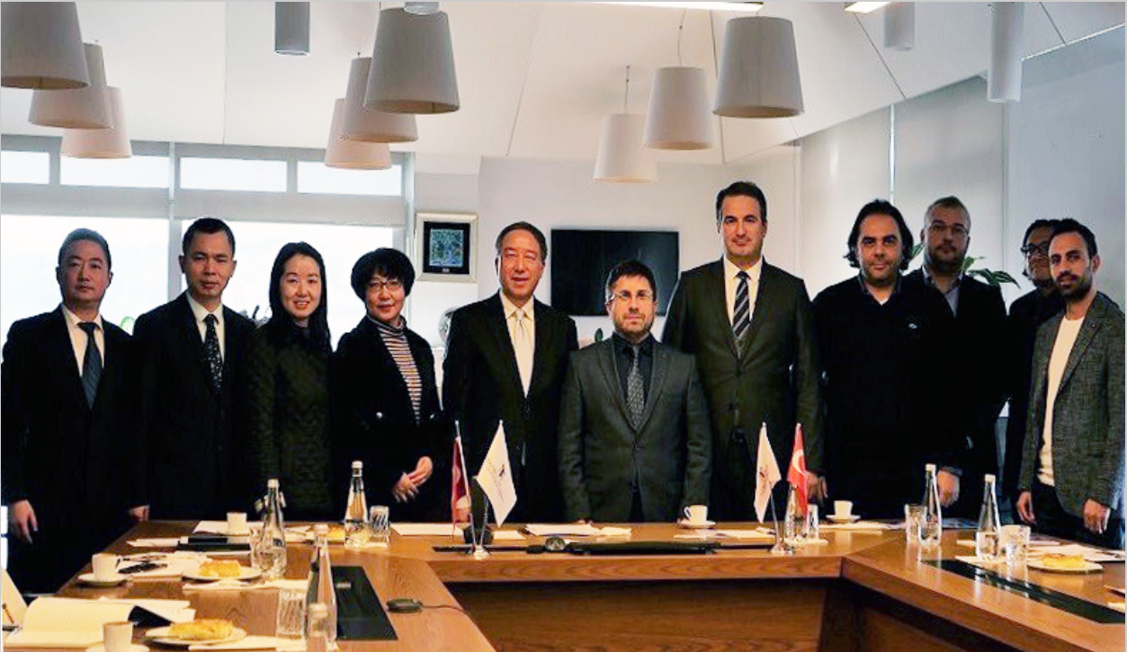
From 5 to 14 December 2019, in order to further promote the implementation of the in-depth opening strategy of Southwestern University of Finance and Economics (SWUFE), broaden cooperation with universities and financial institutions along "Belt and Road" and explore the establishment of "Alliance of Belt and Road Business School", a delegation led by Zhuo Zhi, the President and Deputy Party Secretary of SWUFE, visited friendly cooperative universities in Turkey, Greece and Germany, the Bank of China (Turkey) Co., Ltd., German Allianz Insurance Group and the General Consulate of the People's Republic of China in Munich.
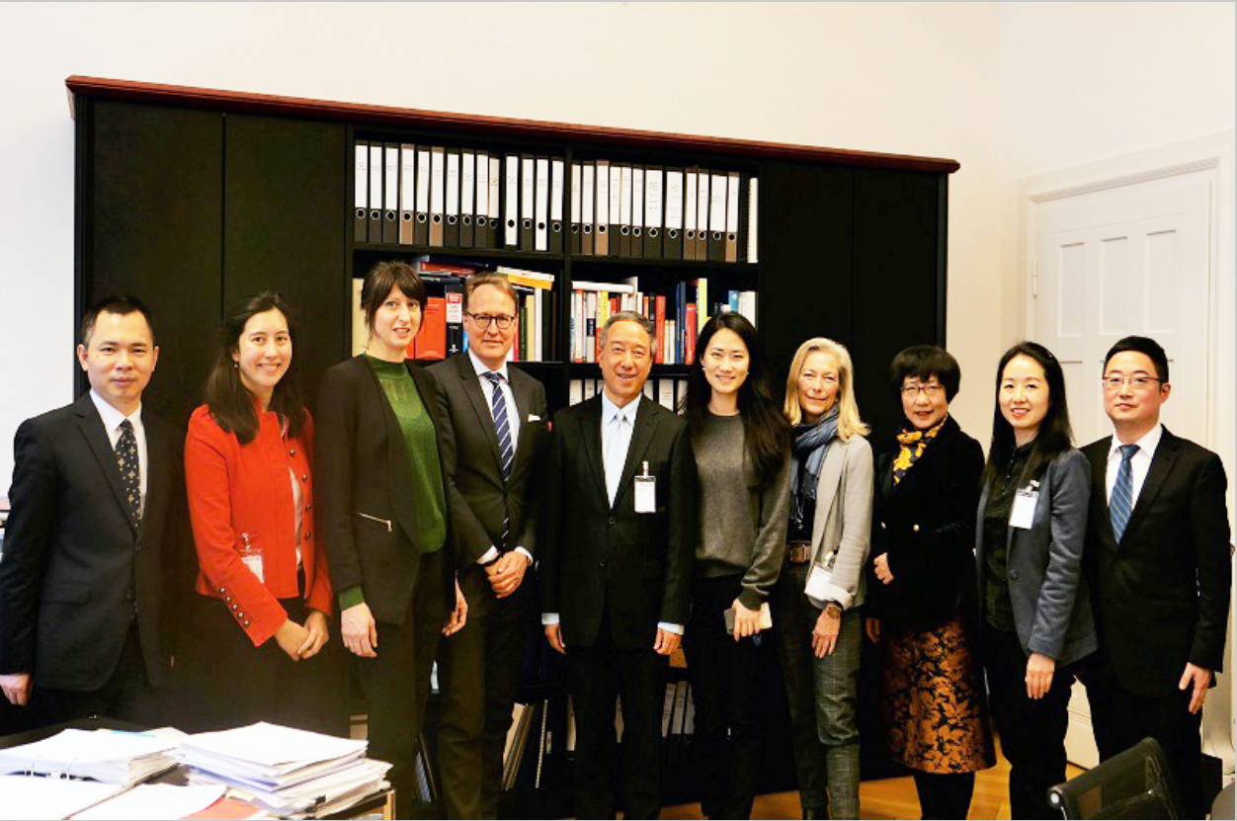
During the visit, the delegation renewed the Memorandum of Understanding with Istanbul Business University in Turkey. The two sides discussed expanding inter-school cooperation within the framework of "Alliance of Belt and Road Business School". In Germany, the delegation visited the Berlin School of Economics and Law in Berlin, which has been cooperated with SWUFE for more than 30 years. To make the visit more fruitful, the delegation made their first official contact with the Athens University of Economics and Business in Greece and the University of Munich in Germany, which ranks 63 in the 2020 QS World University Rankings.
In addition, the delegation also met with the person in charge of Bank of China (Turkey) Co., Ltd. and the headquarters of the German Allianz Insurance Group. They had a comprehensively understanding of the development of Chinese financial institutions in Turkey, exchanged views on the development of China’s insurance market and jointly discussed views on hot issues in the global economy and graduate internship programmes.
At the end of the visit, Zhuo Zhi met with Zhang Yue, the General Consul of the General Consulate of the People's Republic of China in Munich. He introduced SWUFE achievements in international development in recent years, and hoped to have more exchanges and cooperation with Germany, especially universities in Bavaria, under the support of the General Consulate.

The 2020 SBA Chinese and International Students New Year Party

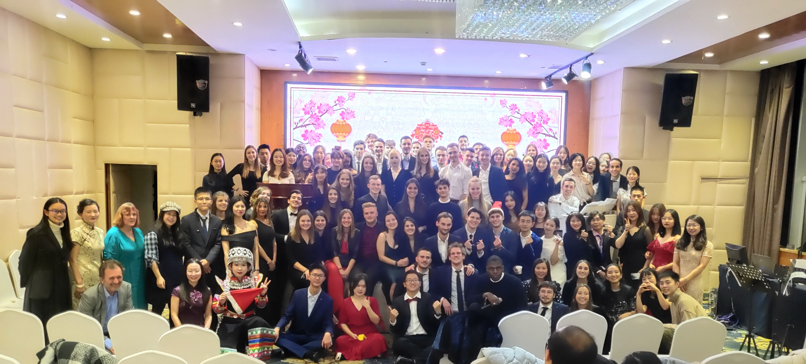
had come to a success
In the evening of 20 December 2019, the 2020 SBA Chinese and International Students New Year Party was officially held. More than 150 participants, including School of Business Administration (SBA) representatives, International Student Association (ISA) members, SWUFE-Nantes Joint Degree Programme students and SBA international students, gathered together to greet the New Year 2020.
Prof Tang Mingfeng, Director of the International Affairs Office and the Sino-French Innovation Research Center of SBA, extended a warm welcome to all the participants and summarized the international events of SBA in 2019. With her announcement, the New Year Party started with variety of brilliant and attractive shows. Jazz dance, Chinese folk song Don’t be afraid, piano performance, saxophone solo Jasmine, dub of Kung Fu Panda and so on, all won great applause from audiences. In addition, teachers in International Affairs Office of SBA and international students from France sang the classic French song La Vie En Rose altogether. The New Year Party was full of laughter and cheerfulness during the whole evening.
2019 is about to come to a successful conclusion. We will keep in mind our original intentions, forge ahead, and continue to be the inheritor and interpreter of Chinese culture in the coming 2020!

SBA Held Pre-trip Training of Spring Study Abroad-Exchange Program of 2020
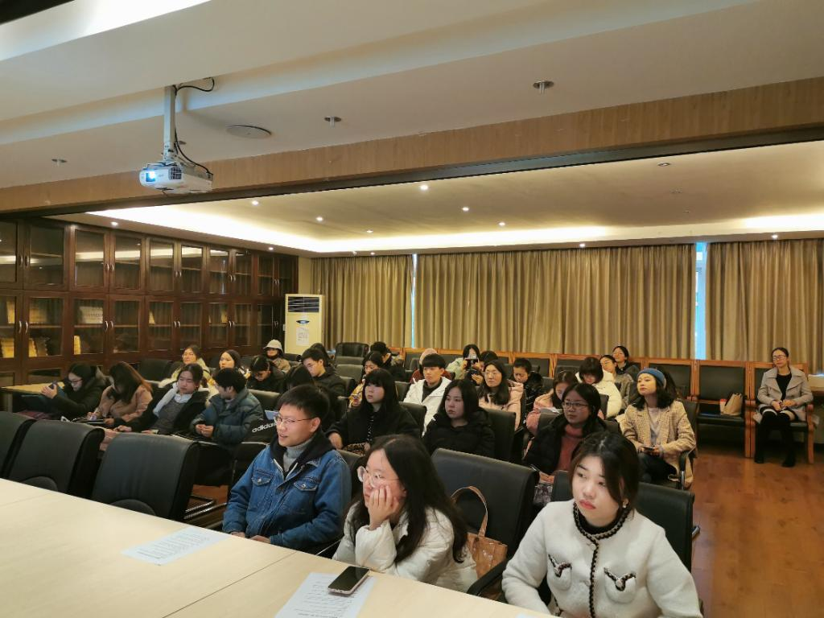
To strengthen the political consciousness and safety awareness of students studying abroad, enhance their cross-cultural communication skills and accomplish the exchange study, on 23 December 2019, International Affairs Office of School of Business Administration (SBA) held a pre-trip training for 43 students who have joined Spring Study Abroad-Exchange Program of 2020.
Teachers in International Affairs Office gave a clear presentation for the procedure of away and back to the universities, overseas matters needing attention and tips of living abroad. Three peers who have finished their exchange study in Audencia Business School in France, University of Passau in Germany and Science & Technology University of Taiwan in China shared everything they knew to the students in the aspects of study, life, and time arrangement.
Prof Tang Mingfeng, Director of the International Affairs Office and the Sino-French Innovation Research Center of SBA, summed up the training with ‘observation, experience and concentration, urging students to observe cultural differences, experience self-growth and learn expertise hard, showing academic faith of benefiting others and spirit of unremitting pursuit imparted by SWUFE.
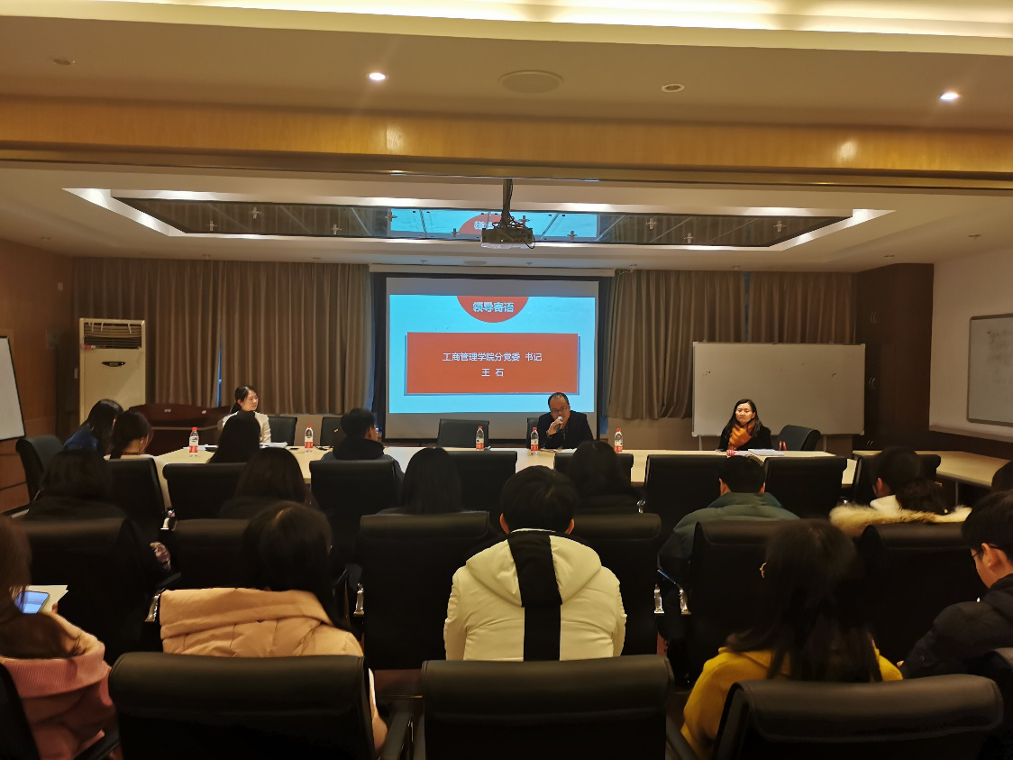
Mr. Wang Shi, Party Secretary of SBA, explained to all students the complicated current situation in politics and economics at domestic and external, potential risks and matters needing attention in study and life when studying abroad. He pointed out that as representatives of Southwestern University of Finance and Economics, we need to heighten our political consciousness, keep a clear mind, and defend homeland interests when we are abroad. Taking the frequent cyber frauds as examples, he reminded everyone to stay alert and increase awareness of self-protection.
All students believed that their exchange study would be fulfilled with highly political consciousness, firm ideal and faith and reasonable study plan.

